Task 10

1/6 – 5/6
(for „take-your-timers 1/6 - 7/6)

FIRST OF ALL,
HAPPY CHILDREN´S DAY!!!!

AND ALL THE BEST TO YOU,
Emilko, Vláďo, Johanko, Hanni, Josefínko, Esterko, Hugo, Oli, Adinko, Verunko, Diviši, Barunko, Leli, Tobi and Berti!!!!



FARM ANIMALS

1. Learn these animal parents and their children. (Project textbook p. 20/1)
Listen and repeat. Opakujte si výslovnost několikrát.
(kdybyste měli problém s přehráním mp3, použijte jako vždy tento odkaz: https://elt.oup.com/student/project/level2/unit2/audio?cc=cz&selLanguage=cs)
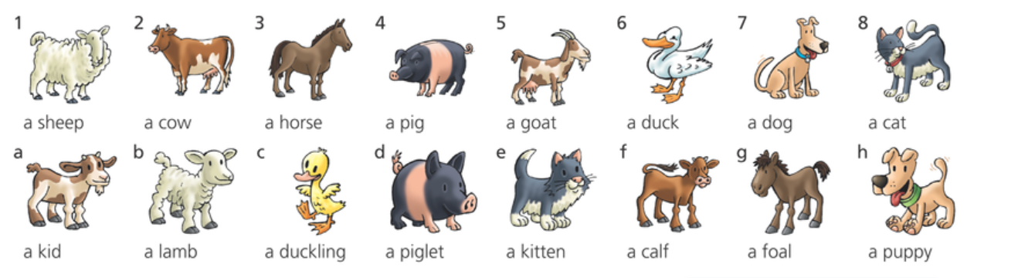
Match the parent with its child:
1 b, 2 ….
2. Listen. Which animal do you hear? Write the young animals, too. ( Textbook 20/2)
1 a goat , a kid
2
3
4
5
6
7
8


3. Listen. Why isn´t Azra at school today? (Textbook 20/3)
Because ……

Listen again. What´s she doing at these times?
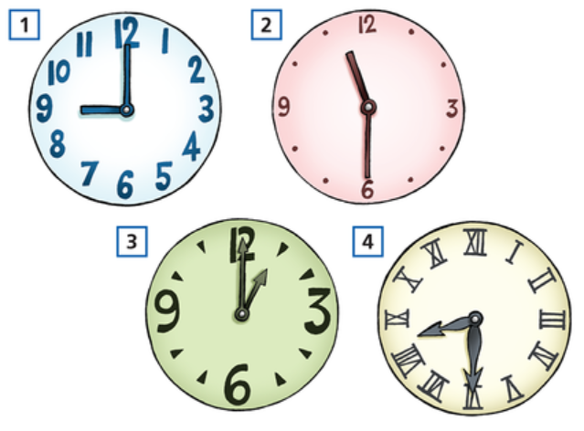

1 She´s waiting for a coach (a bus) with her friends at nine o´clock.
2
3
4

4. Review Present Continuous. Watch this. What animals can you see on the video?

https://www.youtube.com/watch?v=UdEasleUc54

Write the animals here:
1 a fox
2
3
4
5
6

Complete these sentences with Present Continuous. Use red colour.

1 The Clarks ……are having………… (have) such a great time.
2 Lucy and Oliver ………… (not watch) a comedy.
3 Olivia ……………… (sit) at her desk.
4 She ……………….. (not play) games on her phone.
5 I ……………………. (do) my English homework.
6 I ……………………. (not watch) TV now.

5. S tímto úkolem počkejte až po úterním Meetu!!!!

Do you remember Azra and her school trip? Look at these 4 pictures, read the text and correct the sentences.
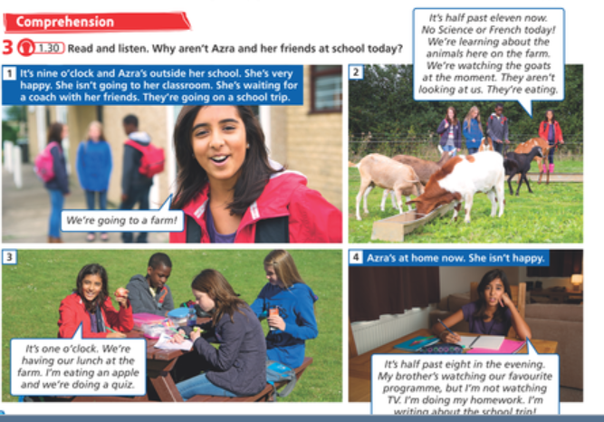

Věty nepište, ale říkejte. Nahrajte se pomocí tohoto online recordéru: https://vocaroo.com/. Zvukový záznam svého hlasu vložte sem.
Takto:
Tvořte celé věty jako je ta modrá.
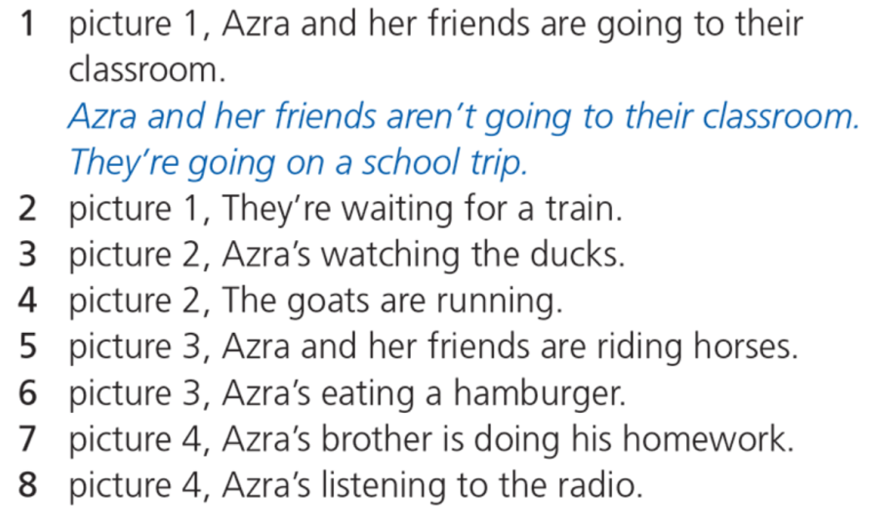

6. Listen. Which animals can you hear? And what are they doing? (Textbook 21/7)
Use these verbs only: fly - swim – run - climb – drink – jump – eat - sleep
1 Pigeons are flying.
2
3
4
5
6
7
8

Check your answers on the next 2 pages and count your points:

ANSWER KEY:
1.
2f, 3g, 4d, 5a, 6c, 7h, 8e _____ / 7 points

2.
2 a dog, a puppy
3 a pig, a piglet
4 a cow, a calf
5 a horse, a foal
6 a duck, a duckling
7 a sheep, a lamb
8 a cat, a kitten _____ /(7x2) 14 points

3.
2 She´s watching the goats at half past eleven.
3 She´s eating an apple / having lunch / doing a quiz at one o´clock.
4 She´s doing her homework at half past eight.
____ / (3x2) 6 points
4.
Animals on the video:
2 a rabbit
3 a bear
4 a deer
5 a squirrel
6 birds _____ / 5 points

Present Continuous sentences:
2 Lucy and Oliver ……aren´t watching / are not watching…… (not watch) a comedy.
3 Olivia ……´s sitting / is sitting………… (sit) at her desk.
4 She ……isn´t playing / is not playing………….. (not play) games on her phone.
5 I ………´m doing / am doing……………. (do) my English homework.
6 I ………´m not watching / am not watching……………. (not watch) TV now.
______/ (5x2) 10 points

5.
_____/ (7x2) 14 points

6.
2 Puppies are eating a bone.
3 Lambs are running.
4 Cows are drinking.
5 Ducklings are swimming (to their mother).
6 Horses are jumping.
7 A cat´s climbing a tree.
8 Piglets are sleeping. _____/ (7x2) 14points

Total_ _____/70 points

AND FINALLY,
A SONG FOR YOU!!!!
Sing along!!!
https://www.youtube.com/watch?v=cV_yOSXVm4k

