Task n. 9 (11.-15.5)
Dear 5 ,
tento týden budeme dále procvičovat řadové číslovky a měsíce v roce.
- Zde si opakovaně pusťte písničku a doplňte do textu chybějící slova:
https://learnenglishkids.britishcouncil.org/songs/time-another-year
Time for another year by Dave Holmes

January, _________, March
April, May and June
July and ________, goodbye summer
Autumn's coming soon.

Hey ___________, October, November
It's December, winter's here
Goodbye Christmas, that's the end
It’s time for another _________.

____________, February, March
April, May and June
___________ and August, goodbye summer
Autumn's coming soon.

Hey September, October, November
It's ___________, winter's here
Goodbye Christmas, that's the end
It’s time for another year.

Goodbye Christmas, that's the end
Time for another year.

- V příloze e-mailu máte pracovní list, který si vytiskněte, vystřihněte si jednotlivá políčka a spojte zápisy dat s jejich čísly.

- Read and match/Spojte věty s obrázky:

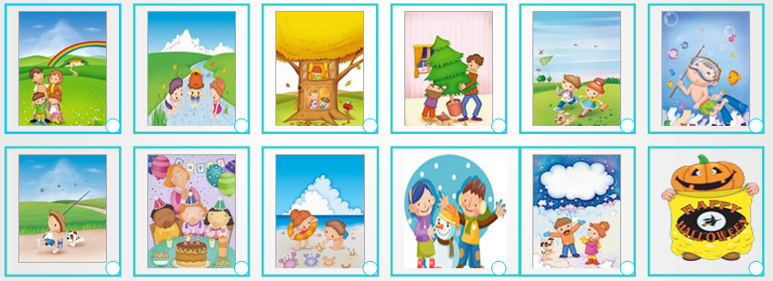

1 IN MAY I PLAY WITH MY FRIENDS IN THE TREE.
2 IN DECEMBER WE HAVEA BIG CHRISTMAS TREE.
3 IN JANUARY IT SNOWS. I WEAR GLOVES.
4 IN SEPTEMBER I GO FISHING WITH MY DOG.
5 IN APRIL I CATCH BUTTERFLIES WITH MY FRIEND.
6 IN NOVEMBER I GO TO THE COUNTRY WITH MY PARENTS.
7 IN FEBRUARY WE MAKE A SNOWMAN.
8 IN AUGUST I GO TO THE BEACH.
9 IN JULY I PLAY IN THE RIVER WITH MY FRIENDS.
10 IN JUNE I GO SNORKELLING.
11 IN OCTOBER I CELEBRATE HALLOWEEN.
12 IN MARCH I CELEBRATE MY BIRTHDAY.

Společně se uvidíme v úterý 12.5. v 11:30 na Meetu, zde je odkaz na přihlášení: https://meet.google.com/nqr-nkoj-pgd

Pošlete vypracované úkoly č. 1, 2 i 3 na email nebo mobil do pátku 15.5.
Have a nice day !
Magdaléna K. a Magdaléna M.

