C A N A D A
Canada is a big and interesting country.
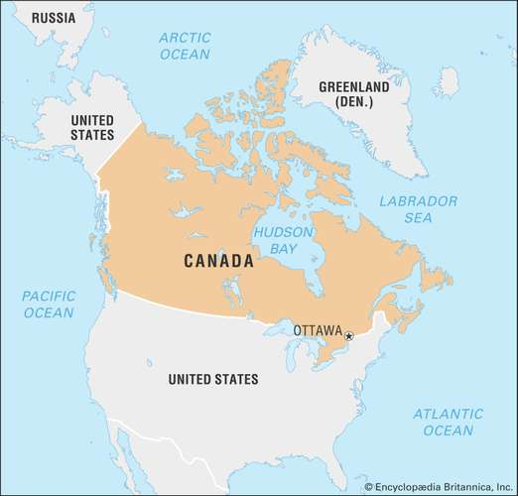
Its capital city is Ottawa. Toronto, Montreal and Vancouver are very big cities. In Canada live about 36 million people.
Over 30% of the country is forest. Canada has 10% of the world's forests! Canada also has more lake area than any other country in the world.
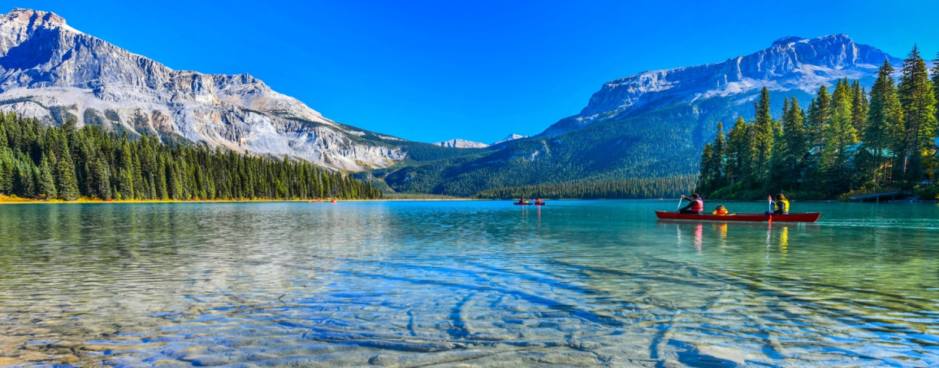

Canada is a very young country. July 1st is Canada Day. Red and white are the national colours.
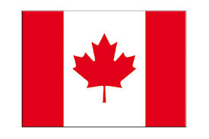
Canada's national animal is a beaver!
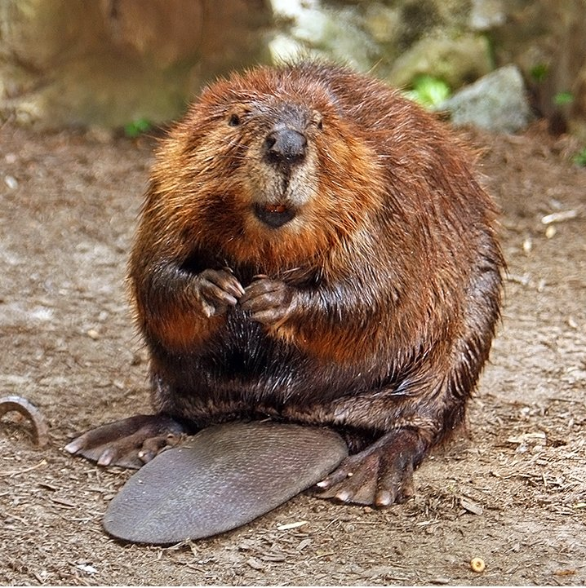
Canada has two national languages, English and French. When many people think of Canada, they think of maple syrup. Maple syrup is a delicious sweet sauce used on pancakes.

Canada has its own Canadian dollar.
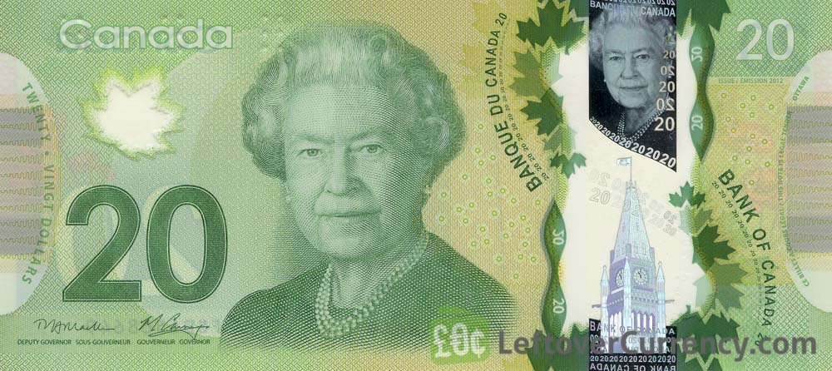
There is very cold in some parts of Canada.
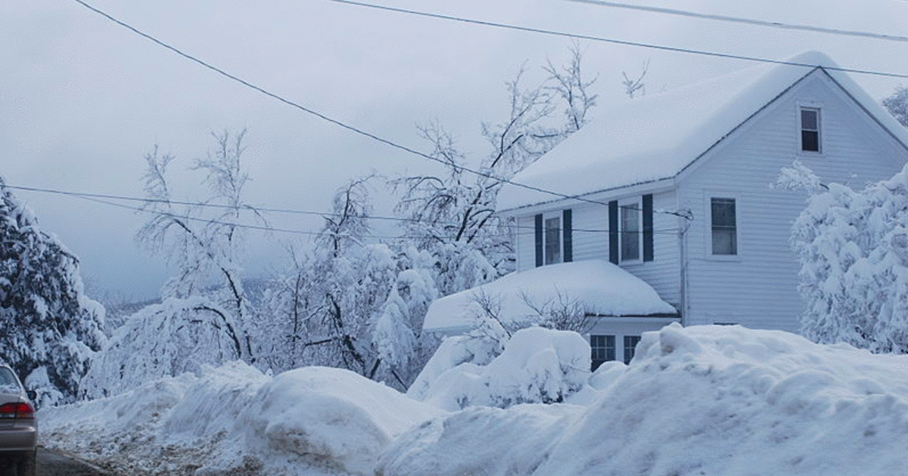
Canadians love ice hockey and most Canadians play it.


